Insert School Logo

**Semester 1 examination, 2021**

**Question/Answer booklet**

**PHYSICS**

**Unit 3**

**Name ____________________________________________________**

**Teacher ____________________________________________________**

**Time allowed for this paper**

Reading time before commencing work: ten minutes

Working time: three hours

**Materials required/recommended for this paper**

***To be provides by the supervisor***

This Question/Answer booklet

Formulae and Data booklet

***To be provided by the candidate***

Standard items: pens (blue/black preferred), pencils (including coloured), sharpener,

correction fluid, eraser, ruler, highlighters.

Special items: up to three non-programmable calculators approved for use in the WACE examinations, drawing templates, drawing compass and a protractor.

**Important note to candidates**

No other items may be taken into the examination room. It is **your** responsibility to ensure that you do not have any unauthorised material. If you have any unauthorised material with you, hand it to the supervisor **before** reading any further.

**Structure of this paper**

|  |  |  |  |  |  |
| --- | --- | --- | --- | --- | --- |
| Section | Number of Questions | Questions to be answered | Suggested working time (minutes) | Marks available | Percentage of exam |
| Section One  Short Response | 11 | 11 | 50 | 54 | 30 |
| Section Two  Problem Solving | 7 | 7 | 90 | 90 | 50 |
| Section Three  Comprehension | 2 | 2 | 40 | 36 | 20 |
| **Total** | 180 | 100 |

**Instructions to candidates**



1. Write your answers in the spaces provided beneath each question. The value of each question (out of 180) is shown following each question.
2. Answers to questions involving calculations should be evaluated and given in decimal form. Final answers should be given up to a maximum of three significant figures and include appropriate units where applicable.
3. Questions containing the instruction “estimate” may give insufficient numerical data for their solution. Give final answers to a maximum of two significant figures and include appropriate units.
4. Despite an incorrect result, credit may be obtained for method and working providing these are clearly and legibly set out.
5. Questions containing specific instructions to “show working” should be answered with a complete, logical, clear sequence of reasoning showing how the final answer was arrived at; correct answers which do not show working will not be awarded full marks.
6. Supplementary pages for the use of planning/continuing your answer to a question have been provided at the end of this Question & Answer booklet. If you use these pages to continue an answer, indicate at the original answer where the answer is continued, i.e. give the page number.
7. Extra/spare graphs have also been provided at the end of this Question & Answer booklet.



**Section One: Short Response 30% (54 marks)**

This section has eleven (11) questions. Answer **all** questions. Write your answers in the spaces provided.

Suggested working time: 50 minutes.

**Question 1 (4 marks)**

A 15 cm long straight wire is placed entirely in a magnetic field at a right angle to the magnetic field. The wire is connected to a power supply and carries a current of 1.2 A.

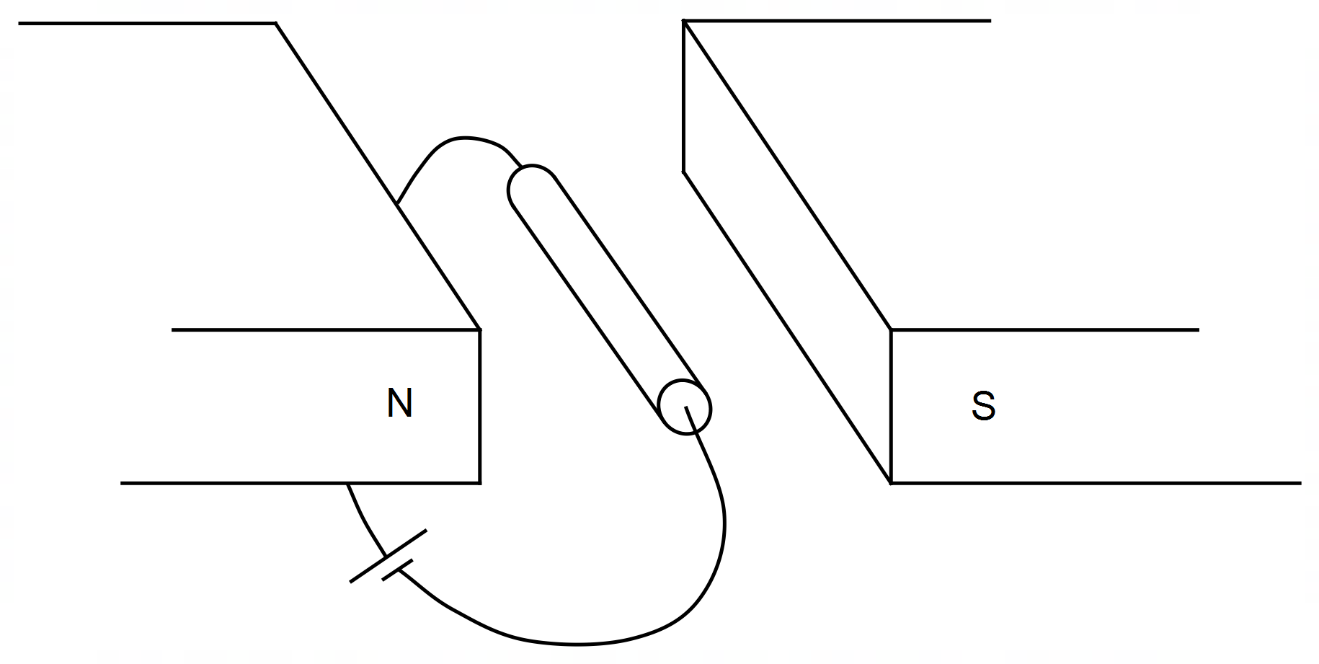

1. (i) Draw an arrow showing the direction of the magnetic field. (1 mark)

(ii) Draw an arrow on the wire to show the direction of the force acting on it. (1 mark)

1. Calculate the magnitude of the magnetic field (B) if the wire experiences a force of 2.7 mN.

(2 marks)

____________________ T

**Question 2 (5 marks)**

An unknown moon of Neptune has an orbital radius of 1.18 × 105 km. The mass of Neptune is 17.3 times larger than the mass of Earth. The major moons of Neptune are given in the table below.

Use your Formula and Data Booklet and data in the table below to determine the unknown moon with an orbital radius of 1.18 × 105 km.

|  |  |
| --- | --- |
| **Moon** | **Orbital Period (Earth days)** |
| Triton | 5.88 |
| Proteus | 1.12 |
| Larissa | 0.55 |
| Galatea | 0.43 |
| Despina | 0.33 |
| Thalassa | 0.31 |
| Naiad | 0.29 |

Unknown Moon ______________________

**Question 3 (6 marks)**

An 80.0 kg bricklayer places a 3.90 m long ladder against a vertical brick wall as shown and climbs two-thirds of the way up the ladder. The uniform ladder has a mass of 12.0 kg and the brick wall can safely withstand a horizontal force of 300 N at point A without toppling.

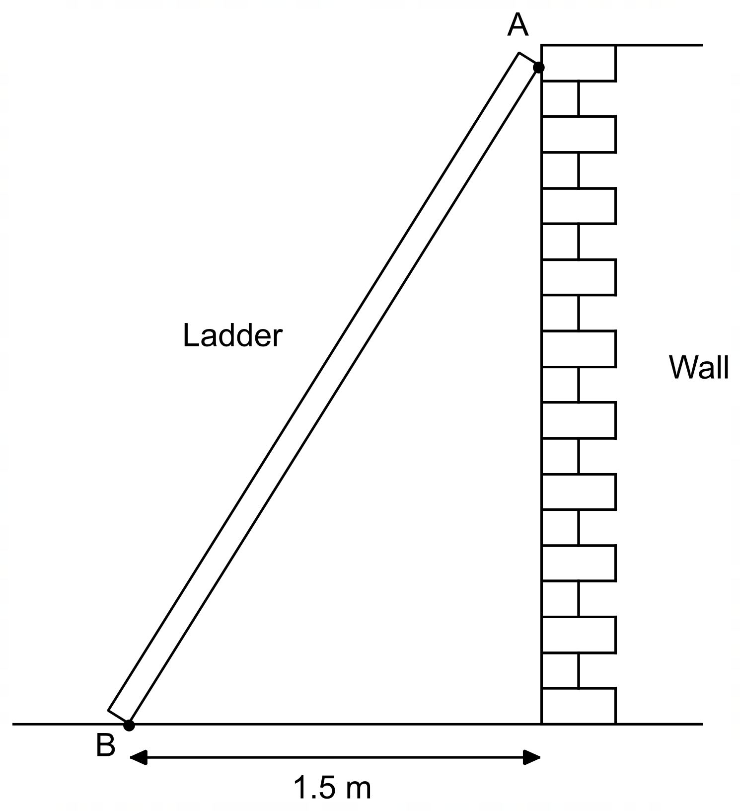

1. Evaluate with calculations whether this situation is safe when the bricklayer is in the position described. (4 marks)
2. The bricklayer now moves to a position three-quarters up the length of the ladder. Explain how this makes the situation less safe. (2 marks)

__________________________________________________________________________

__________________________________________________________________________

__________________________________________________________________________

__________________________________________________________________________

**Question 4 (6 marks)**

A small bar magnet is dropped from rest through the centre of a coil of wire which is attached to a sensitive voltmeter, as shown below. Points A and C are the ends of the coil and point B is midway through the coil. The induced emf between points A and B is plotted on the graph below, where *t A*, *t B* and *t**C* are the times when the magnet is at positions A, B and C respectively.

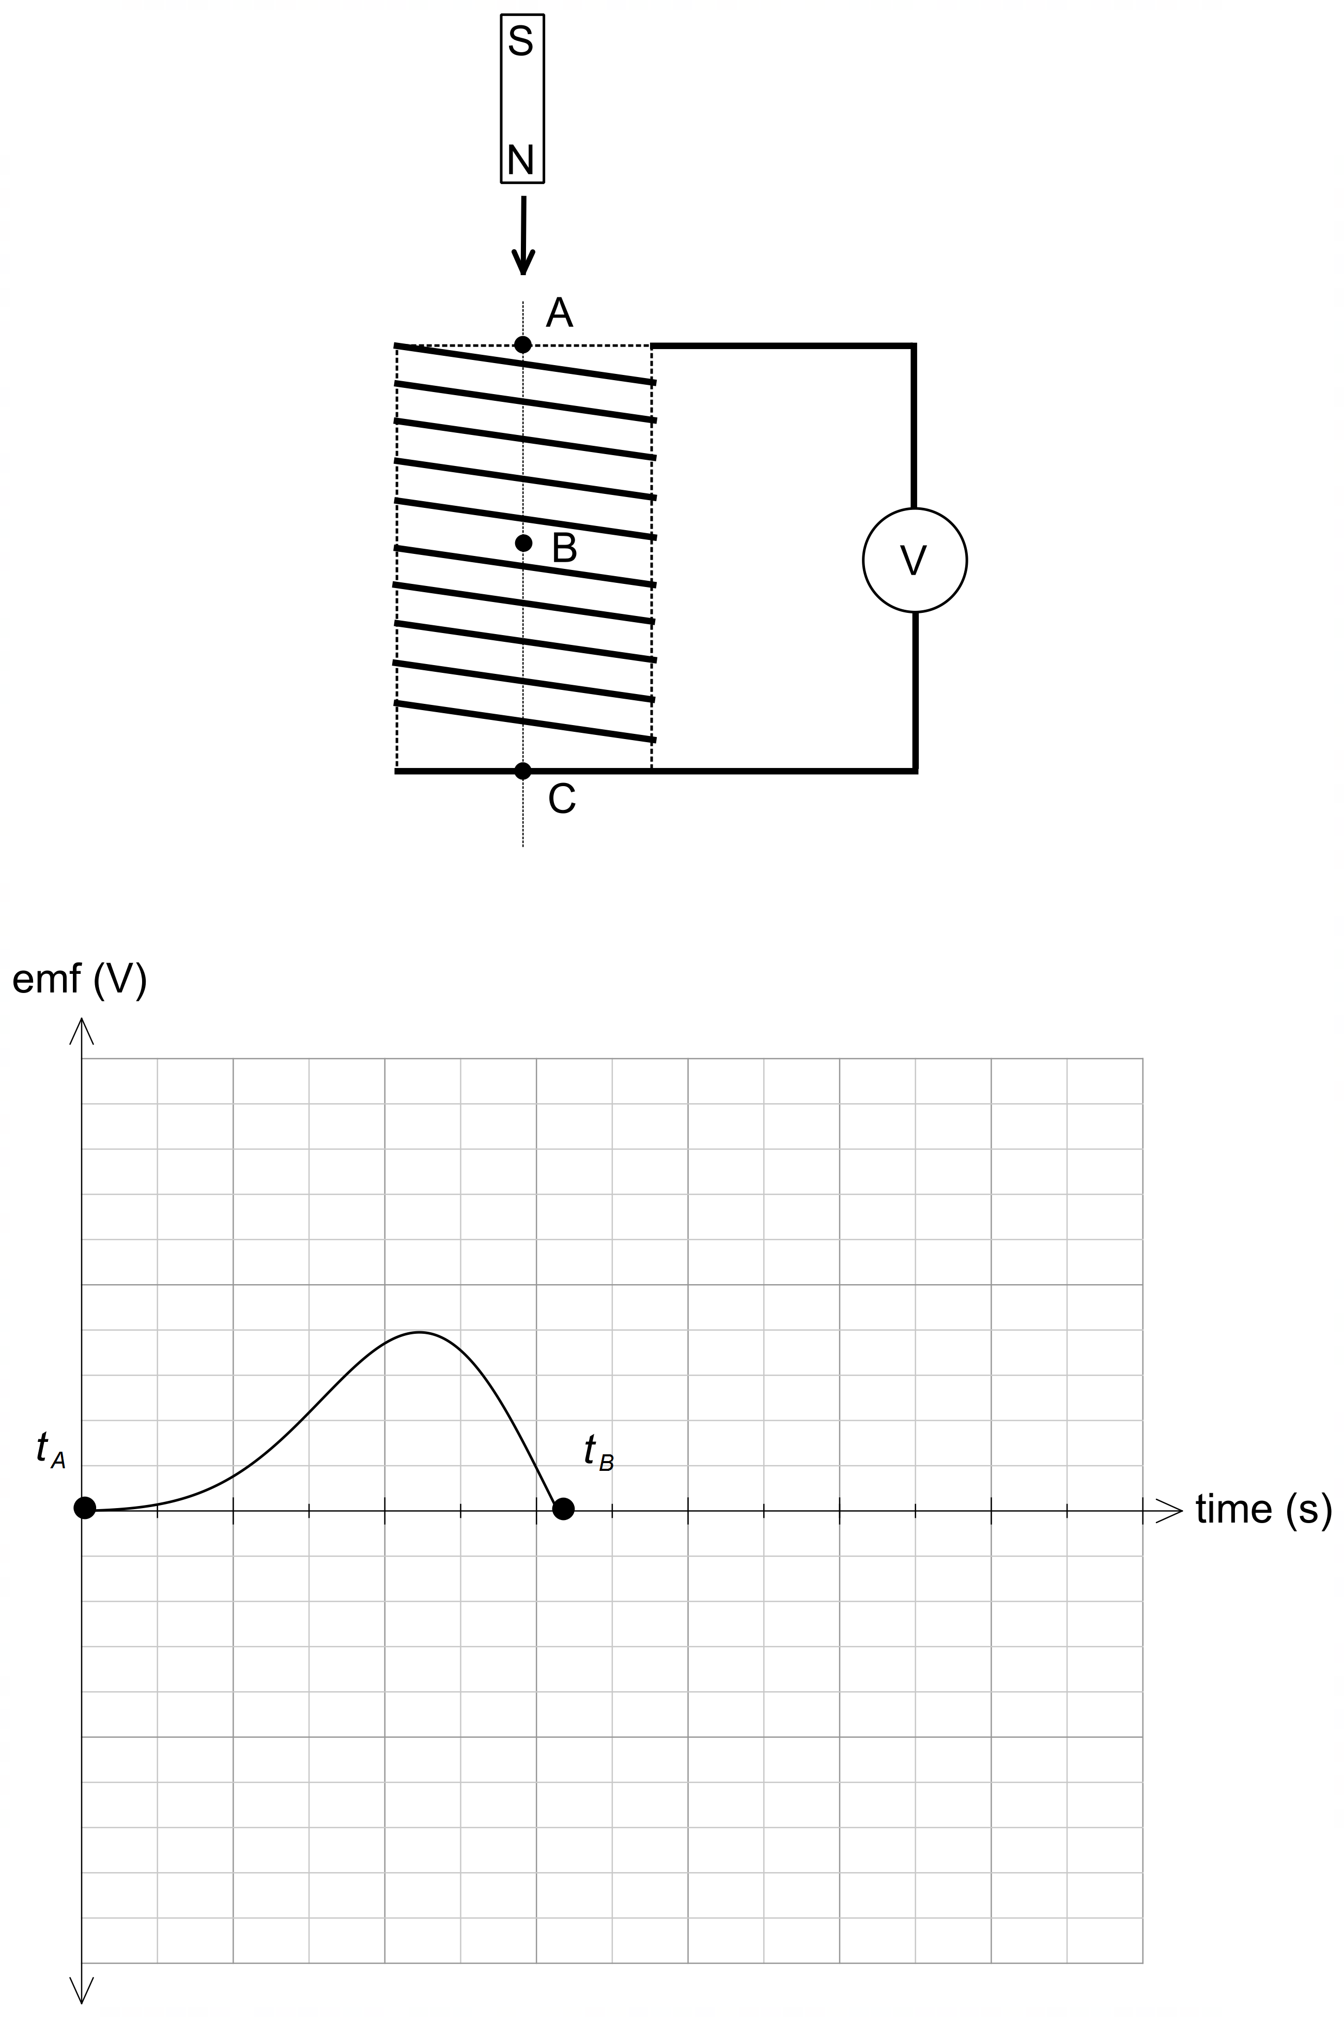

1. Complete the plot of the induced emf in the coil for the period the magnet moves between B and C. This will require you to mark and label *t C* on the graph. Ignore any effects of the Earth’s magnetic field. (2 marks)
2. The following changes are then made to this experiment:
   1. This equipment is now placed in an external vertical magnetic field. The external magnetic field is twice the strength of the magnetic field of the magnet. With reference to relevant Physics concepts, explain the effect on the output emf. (2 marks)

____________________________________________________________________

____________________________________________________________________

____________________________________________________________________

____________________________________________________________________

____________________________________________________________________

* 1. This experiment is now performed on a planet where the acceleration due to gravity is 19.6 m s–2. Draw the resulting emf output on the graph above for this location. (2 marks)

**Question 5 (3 marks)**

The electric field surrounding two charged particles A and B is shown below. The force on particle B is also indicated. Deduce the polarity and relative magnitude of the charges on particles A and B and indicate the force on particle A by drawing a vector on the diagram below.

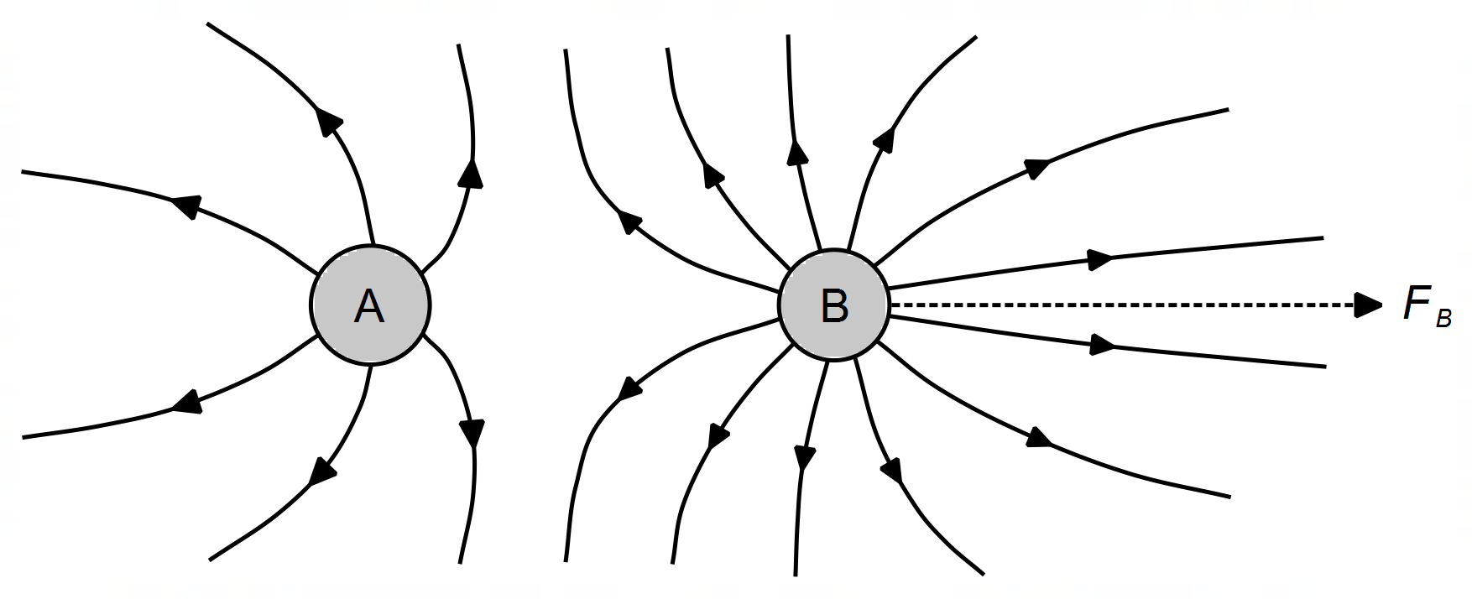

_______________________________________________________________________________

_______________________________________________________________________________

_______________________________________________________________________________

_______________________________________________________________________________

**Question 6 (6 marks)**

Two Styrofoam pith balls are moving in an evacuated chamber. The pith balls are equally but oppositely charged, and each has a mass of 185 mg. At a certain time both balls are captured by the other’s electric field such that both revolve around a central point at a rate of 54 revolutions per minute, as shown in the diagram.

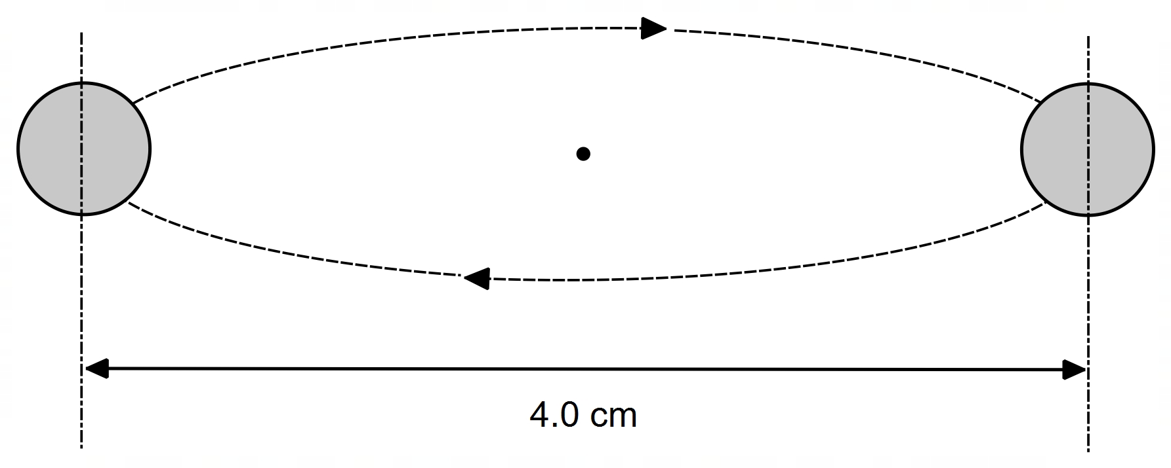

Determine the magnitude of the charge on each pith ball.

______________________ C

**Question 7 (3 marks)**

A BMX rider is travelling through a dip on a track where the dip is part of a vertical circle of radius 5.0 m. At the bottom of this dip, the rider experiences a reaction force from the ground of 1075 N. Calculate the speed of the rider through this part of the track. The combined mass of the rider and bicycle is 75 kg. (Note: ignore the effects of friction)

______________________ m s–1

**Question 8 (4 marks)**

A non-ideal intermediate transformer accepts electrical energy from a long-distance transmission line at a rate of 270 MW and has an output voltage of 13.0 kV. After the intermediate transformer, electrical energy is delivered to a local transformer at a rate of 231 MW and 11.5 kV along a 2.50 km long line, having a resistance rating of 0.075 Ω km–1. Determine the percentage efficiency of the intermediate transformer. Show working.

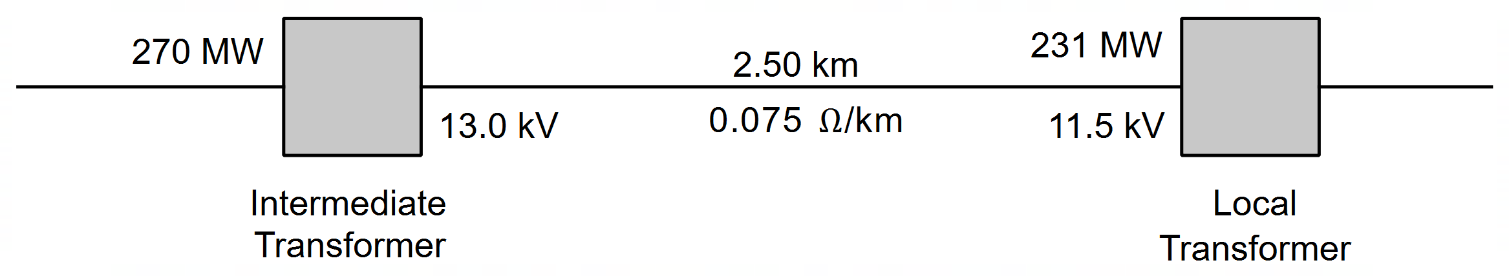

Efficiency __________________ %

**Question 9 (7 marks)**

A counterweight and pulley are being used to roll a 163 kg trolley up an inclined slope. The counterweight contains four 15 kg bags of cement and is attached to the trolley with a light rope. The surface slopes upwards at an angle of 11° to the horizontal. Assume an average frictional force of 60 N between the trolley and the inclined slope.

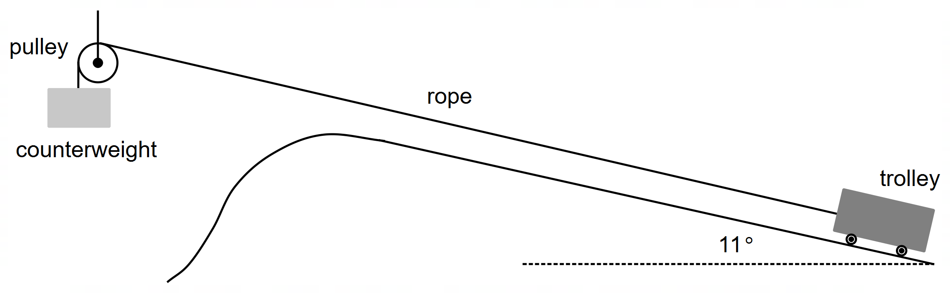

1. Show that the trolley accelerates up the slope at exactly 1.00 m s–2. (6 marks)

1. Unfortunately, two of the bags of cement were not attached securely and dropped off the counterweight shortly after the trolley began moving. Which of the following graphs best describes the entire journey of the trolley on the slope? Circle your answer. (1 mark)

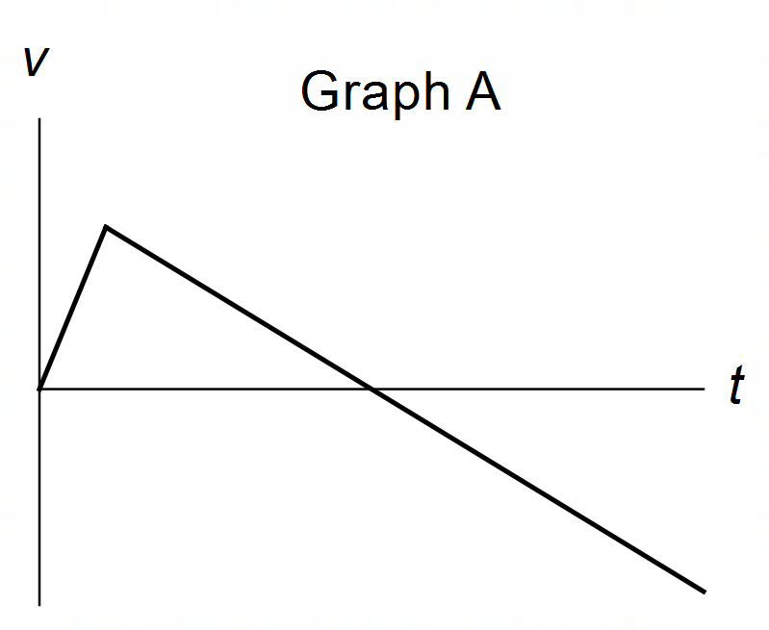 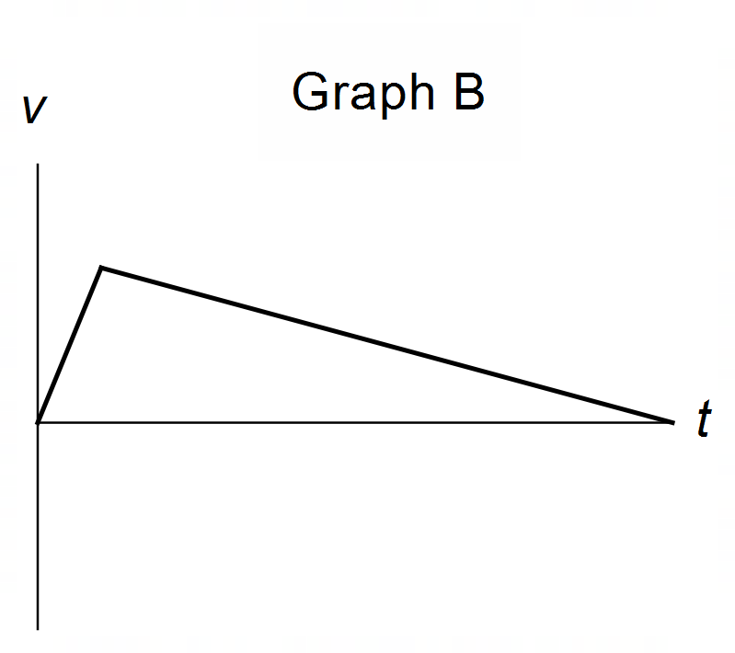 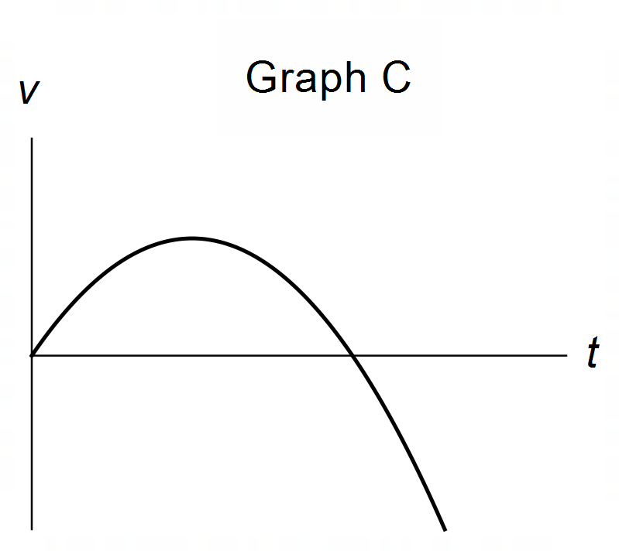

**Question 10 (7 marks)**

A student sets up a simple DC motor, consisting of a square coil of wire sitting in the region between the north and south poles of two magnets. The coil is connected to a commutator.

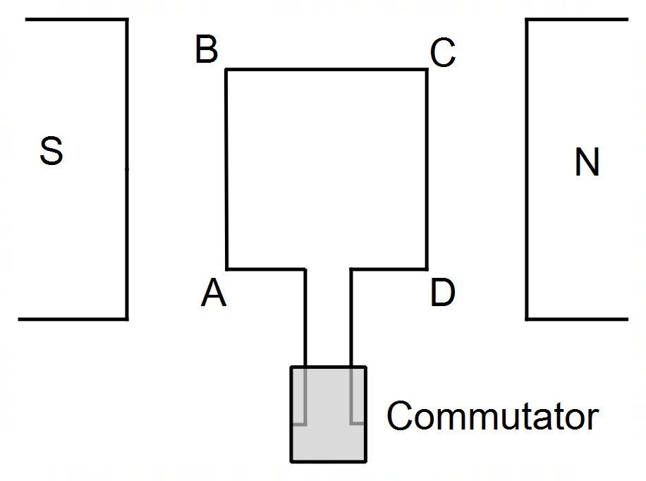

The coil has 15 loops of wire, side lengths 10.0 cm and a current flowing of 1.50 A. The strength of the magnetic field in the region of the coil is 0.55 T. At the instant shown the coil spins clockwise as viewed from side BC.

1. Indicate on the diagram above the direction of the current flowing in the coil. (1 mark)
2. Calculate the magnitude of the torque on the coil when it is in the position shown. (3 marks)

__________________ Nm

1. The student notices that once the motor is turned on for a short period, it quickly maintains a constant rotational speed. Explain this observation, using relevant Physics concepts. Ignore mechanical friction. (3 marks)

__________________________________________________________________________

__________________________________________________________________________

__________________________________________________________________________

__________________________________________________________________________

__________________________________________________________________________

**Question 11 (3 marks)**

An AC generator produces a peak voltage of 3.18 kV. The coil is circular with a diameter 26 cm and sits in a magnetic field of 9.00 × 10-2 T.

The graph below shows the variation of voltage generated with time.

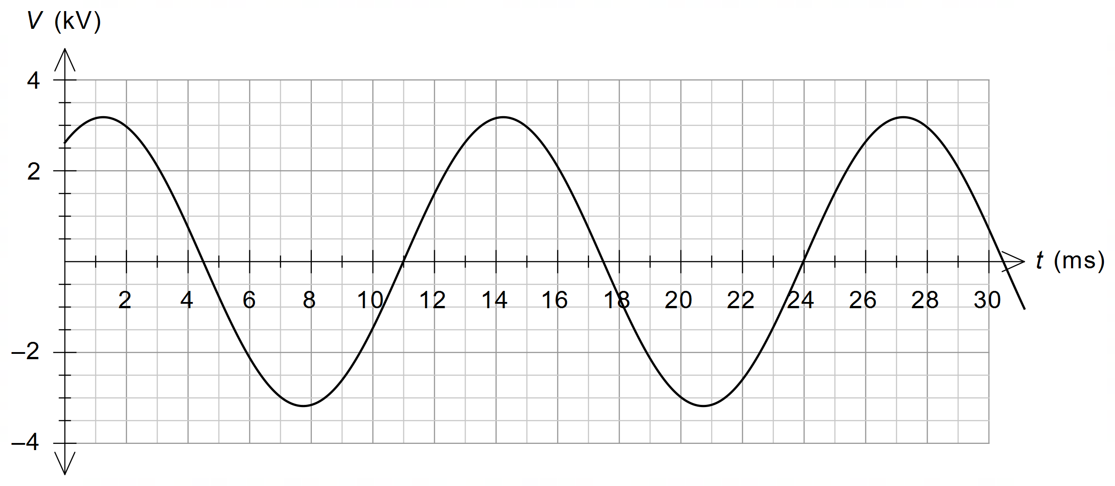

Use this information to **estimate** the number of turns of wire in the generator coil.

Give your answer to an appropriate number of significant figures.

Number of turns __________________

**END OF SECTION ONE**

**Section Two: Problem Solving 50% (90 marks)**

This section contains seven (7) questions. Answer **all** questions. Answer the questions in the space provided.

Suggested working time is 90 minutes.

**Question 12 (14 marks)**

There is a new space mission in 2021 aimed at placing more exploration equipment on planet Mars by the beginning of 2022. The spacecraft transporting the equipment to Mars is called Mars2021. The spacecraft mostly relies on the gravity of both Earth and Mars to navigate its way to Mars.

Mars has a 3390 km radius and a mass of 6.39 × 1023 kg and the spacecraft has a mass of 1025 kg.

On its approach to Mars, the spacecraft descends from an unstable orbit of altitude 4000 km whilst moving with a speed of 1.95 km s–1, to a stable orbit with an altitude of 500 km, as shown below.

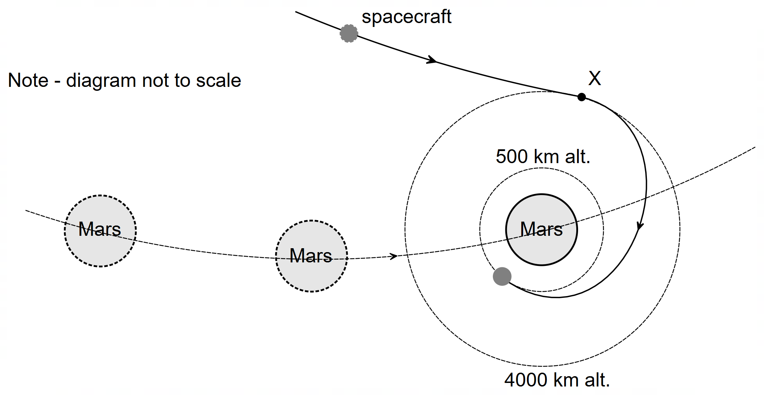

1. Calculate the orbital speed that the spacecraft should have at the location indicated by X for it to maintain a stable orbit at an altitude of 4000 km. (4 marks)

_________________ km s–1

1. Using your answer to part (a), given data and relevant physics concepts, explain why the Mars2021 will continue to descend from an altitude of 4000 km. (3 marks)

The graph below shows how the gravitational field strength of Mars varies with *r*, the distance from the centre of Mars. The dashed line indicates the surface of Mars.

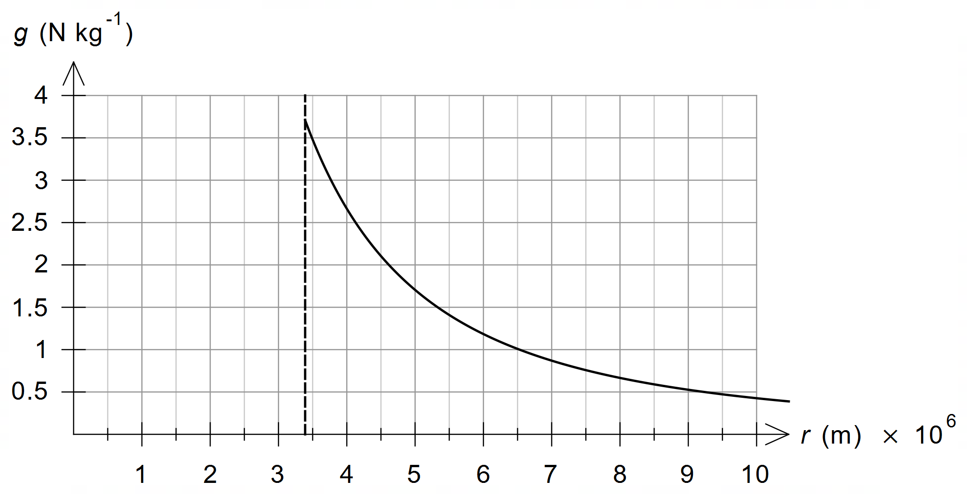

1. Use the area under the graph to estimate the change in potential energy of the spacecraft as it descends from an altitude of 4000 km to an altitude of 500 km. Show working. (3 marks)

__________________ J

1. Using your answer to part (c), determine the final speed of the spacecraft as it reaches an altitude of 500 km altitude. [Note: if you did not get an answer to part (c) use 5 GJ for the change in potential energy] (4 marks)

_________________ km s–1

**Question 13 (15 marks)**

The primary coil of a 9.0 kW step-up transformer is drawing power from a generator. The primary coil draws a peak current of 25 A. The secondary coil of the transformer has 555 turns of wire and produces a peak voltage 5.4 kV. Assume the transformer is ideal.

1. Determine the ratio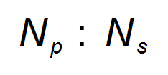in its simplest form. (3 marks)

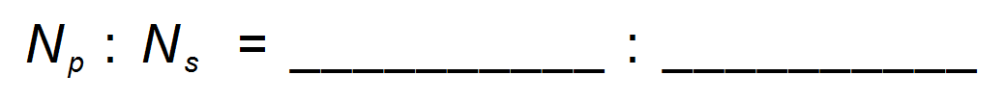

1. Determine the number of turns of wire in the primary coil. (1 mark)

______________ turns

1. Determine the RMS current on the secondary side of the transformer. (3 marks)

_______________ A

1. State and explain one (1) possible source of power loss within non-ideal transformers. (3 marks)

__________________________________________________________________________

__________________________________________________________________________

__________________________________________________________________________

__________________________________________________________________________

__________________________________________________________________________

1. With reference to the principles of electromagnetic induction and/or Faraday’s Law, explain how the voltage in the primary coil of this transformer is transformed to the stated voltage in the secondary coil. (5 marks)

__________________________________________________________________________

__________________________________________________________________________

__________________________________________________________________________

__________________________________________________________________________

__________________________________________________________________________

__________________________________________________________________________

__________________________________________________________________________

__________________________________________________________________________

__________________________________________________________________________

__________________________________________________________________________

__________________________________________________________________________

__________________________________________________________________________

__________________________________________________________________________

**Question 14 (18 marks)**

Jim has just mown his grass and is watering it with a garden hose. The hose is being held at angle of 36° to the horizontal and the water is exiting the hose at a speed of 12.2 m s-1. Ignoring air resistance:

1. Calculate the vertical and horizontal components of the initial speed of the water as it exits the hose. (2 marks)

horizontal ______________ m s–1

vertical ______________ m s–1

1. Determine the height above the ground the water is being released from if the water travels a horizontal distance of 16.0 m to the far edge of the lawn. (4 marks)

height ______________ m

1. Determine the maximum height the water reaches above the end of the hose. (3 marks)

height ______________ m

Consider the vertical motion of a water droplet that has just left the hose.

1. Using the information in the question, draw a velocity-time graph and an acceleration-time graph for the water droplet for the period between leaving the hose and hitting the grass. Assume that upwards is a positive frame of reference. Indicate and label all key features of each graph. Ignore the effects of air resistance for this question. (6 marks)

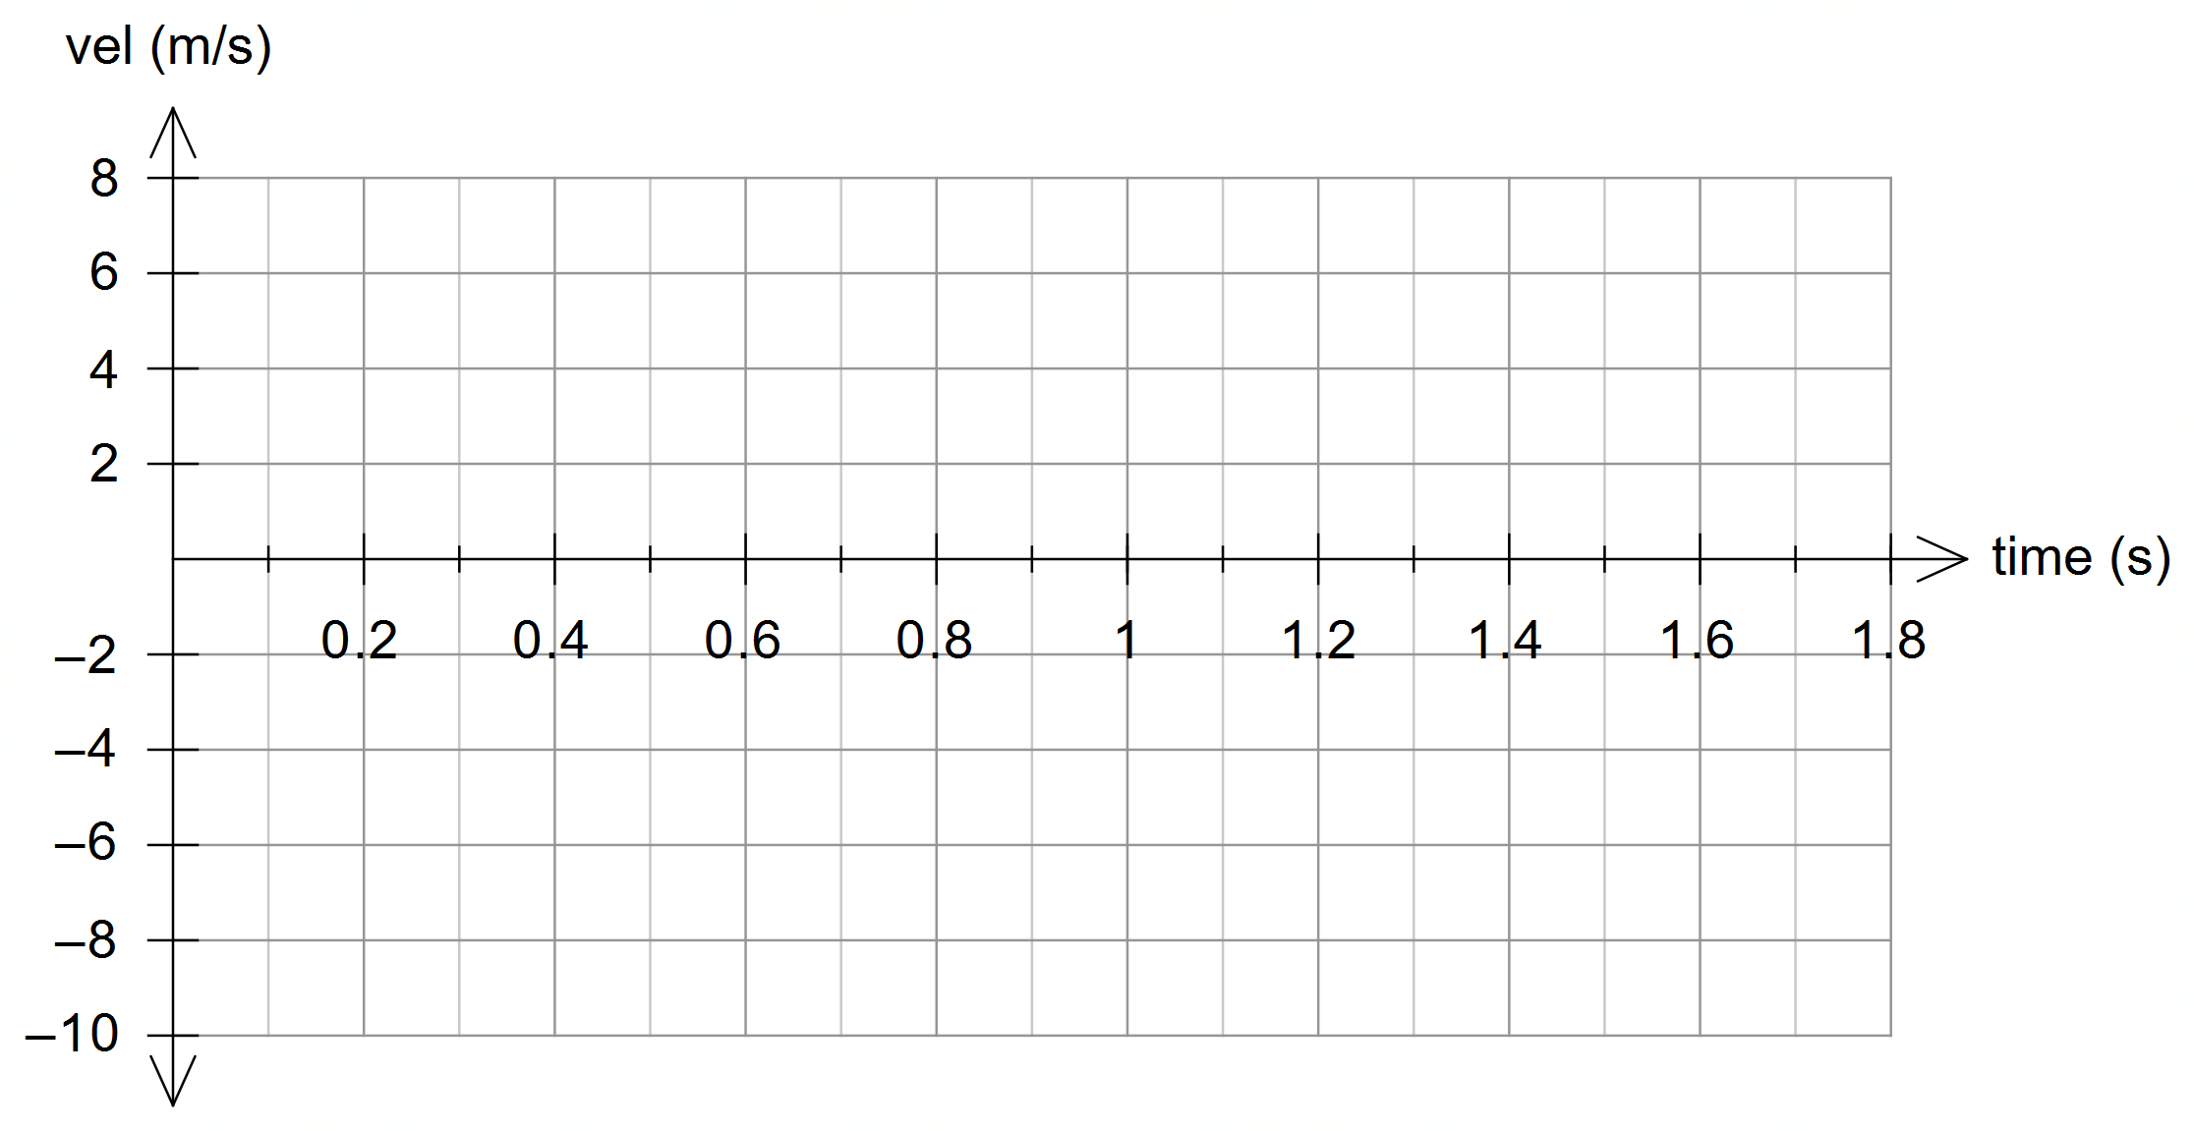

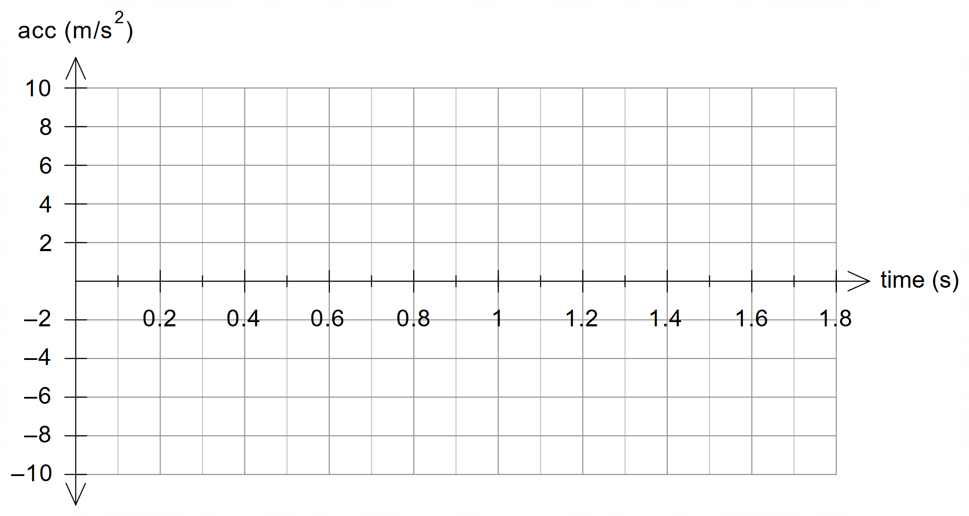

1. State three (3) ways in which the motion of a water droplet exiting the hose is affected by drag force due to air resistance. (3 marks)

__________________________________________________________________________

__________________________________________________________________________

__________________________________________________________________________

__________________________________________________________________________

**Question 15 (15 marks)**

A proton is released in the region between two parallel plates 50.0 cm apart. The proton is given an initial kinetic energy such that it moves horizontally at 1.50 × 105 m s–1. A vertical magnetic field *B* exists in this region and has a strength of 8.80 × 10-3 T as shown. The top and bottom metallic plates have electrical potentials of +1.40 kV and +3.00 kV respectively.

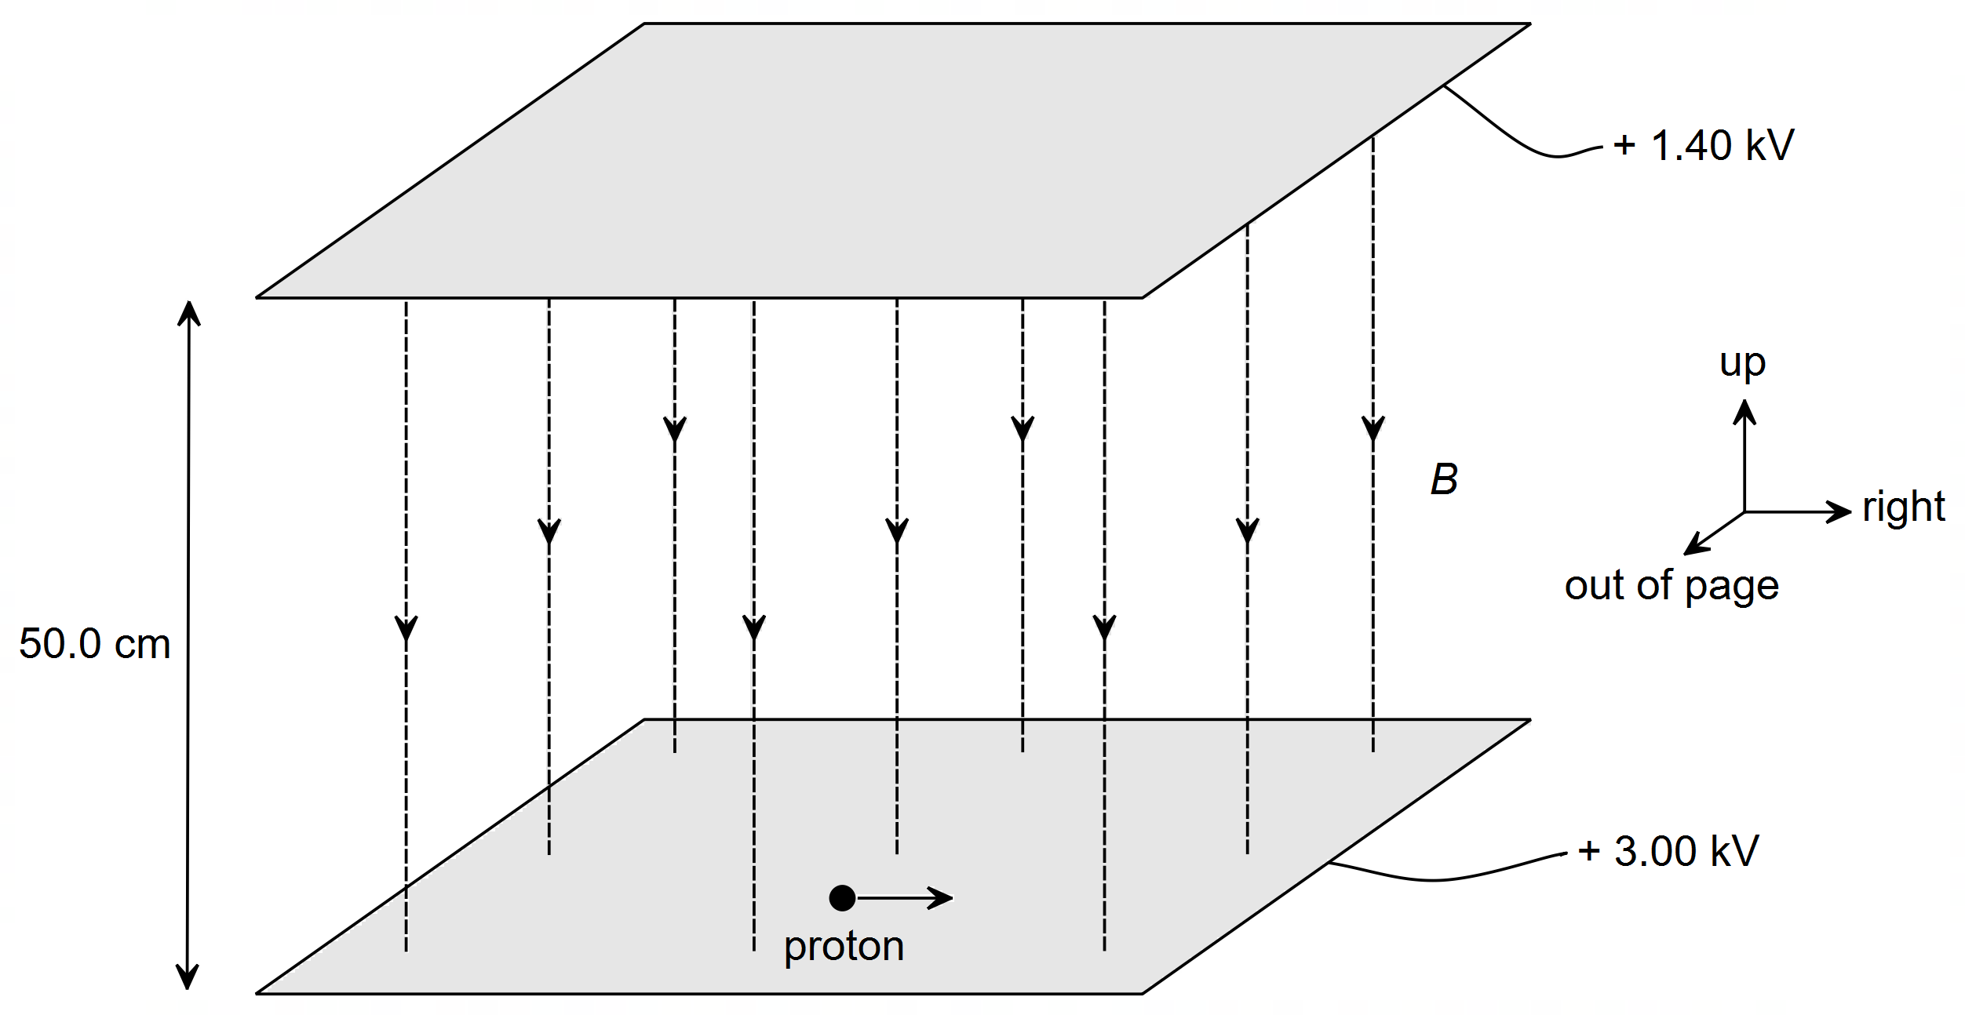

1. On the diagram above, draw and label the electric field *E* in the region between the two plates. Draw at least four (4) field lines. (2 marks)
2. Using convention for the direction shown in the diagram above, indicate the direction of the forces acting on the proton, due to the magnetic and electric field when the proton is first released. The first one has been done for you. (2 marks)

The direction of the **GRAVITATIONAL** force would be:

Up Down Right Left Into page Out of page

The direction of the **MAGNETIC** force would be:

Up Down Right Left Into page Out of page

The direction of the **ELECTRIC** force would be:

Up Down Right Left Into page Out of page

1. Determine the magnitude and direction of the net force on the proton when it is released in the region. You may ignore gravity. (5 marks)

Net force ____________________ N

Angle to the vertical ____________________ °

1. Calculate the work done by the electric field as it moves through the entire region. (2 marks)

Work ______________________ J

1. An observer watching the proton being released notices that the proton begins to move upward in a spiral. It is observed that the spiral has a constant radius but an ever-increasing distance vertically between rotations. Account for this motion. (4 marks)

__________________________________________________________________________

__________________________________________________________________________

__________________________________________________________________________

__________________________________________________________________________

__________________________________________________________________________

__________________________________________________________________________

__________________________________________________________________________

__________________________________________________________________________

**Question 16 (12 marks)**

A 6.0 m square single loop of wire on a space station is travelling at a constant speed in the direction indicated towards a straight length of wire on another space station carrying a current of 8.5 A in the direction shown. The centre of the square loop of wire travels 72 m from position A to position C in a short period of time. Position B is located 9.0 m from the wire.

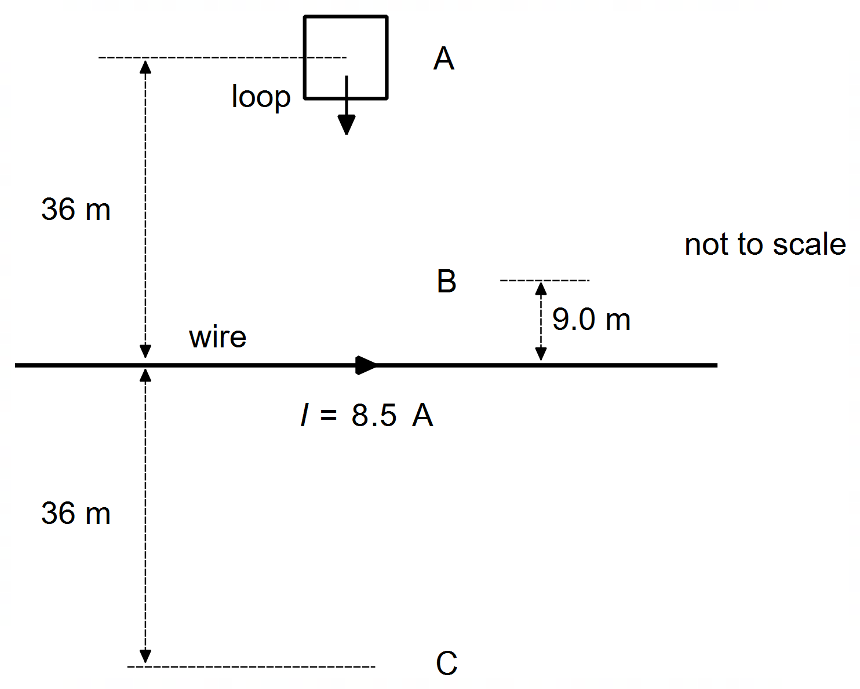

1. As the centre of the coil moves from point A to B, it experiences an average induced EMF equal to 2.50 × 10–6 V. Determine the speed of the coil. (6 marks)

_______________ m s–1

1. Will the induced EMF in the coil be greater at point A or point B? Justify your choice. No calculations are needed. (3 marks)

__________________________________________________________________________

__________________________________________________________________________

__________________________________________________________________________

__________________________________________________________________________

__________________________________________________________________________

1. On the diagram above, draw the coil at point C and indicate the direction of the induced current in the coil at this location. With reference to a relevant physics concept, explain the reason you drew the current in the direction you did. (3 marks)

__________________________________________________________________________

__________________________________________________________________________

__________________________________________________________________________

__________________________________________________________________________

__________________________________________________________________________

**Question 17 (7 marks)**

An air conditioner is supported on an outside wall by an angled bracket as shown below. The 20.0 kg bracket is angled at 120° (as shown below) to fit the angle of the inclined wall so that the air conditioner sits horizontally. The bracket is attached to a pivot point P and is fastened to the wall with a bolt at point B. The bolt can withstand a tensile force of 2.29 × 103 N before breaking. You may assume that the bolt is attached at the end of the upper section of the bracket and that the air conditioner is a uniform object.

The distance *d* = 20 cm; the distance from the pivot to the end of the horizontal section *L* = 110 cm; and the centre of mass (CoM) of the entire bracket is 45 cm from point P.

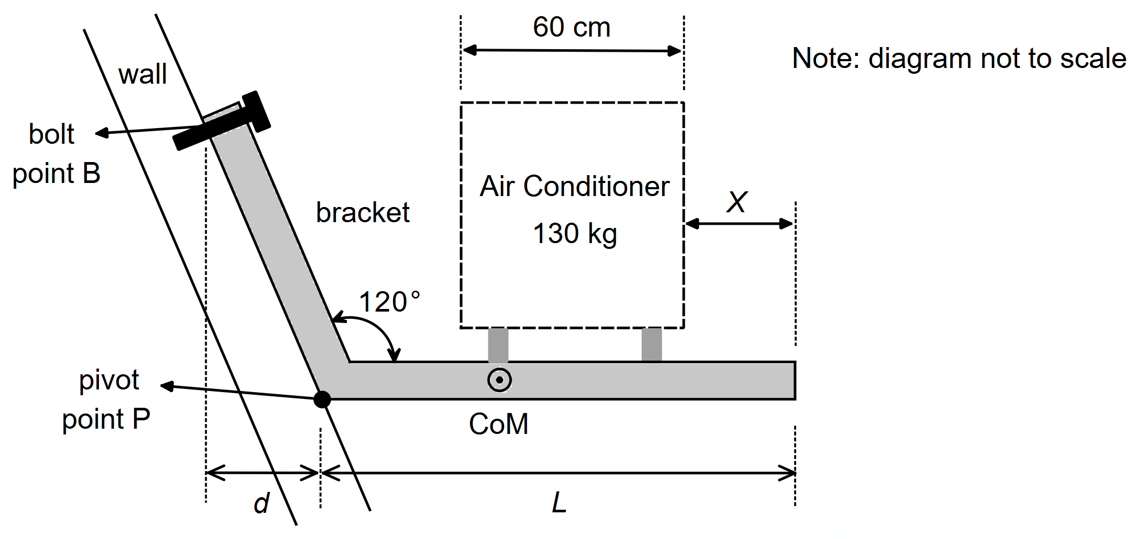

Determine *X*, the minimum safe distance the air conditioner can be from the end of the support.

distance *X* _______________ m

**Question 18 (9 marks)**

A science teacher was twirling a ball on a string as a demonstration of horizontal circular motion. One of the students noticed that the string always dipped at an angle below the horizontal. Let θ be the angle the string makes with the horizontal. Assume the string has negligible mass.

1. With reference to specific forces, explain why the string always makes an angle dipped below the horizontal when the ball is twirling horizontally. (3 marks)

__________________________________________________________________________

__________________________________________________________________________

__________________________________________________________________________

__________________________________________________________________________

__________________________________________________________________________

1. Calculate θ if the mass of the ball is 1.00 × 102 grams, the ball traces a circle of 1.0 m radius and the ball passes around the teacher’s head once every second. (3 marks)

Angle θ ____________ °

1. How would the tension in the string change if the ball were made to move faster? No calculations are necessary. Use a relevant formula to justify your response. (3 marks)

__________________________________________________________________________

__________________________________________________________________________

__________________________________________________________________________

__________________________________________________________________________

__________________________________________________________________________

**END OF SECTION TWO**

**Section Three: Comprehension 20% (36 marks)**

This section has two (2) questions. Answer **both** questions. Answer the questions in the spaces provided.

Suggested working time: 40 minutes.

**Question 19 (18 marks)**

**Friction on Banked Curves**

For a car travelling in a straight line, the forces acting on the car are its weight force downwards; the normal force due to the road on the car acting upwards.

For a car which is turning a corner on a horizontal surface, such as a road, the car will have to rely solely on friction to push the car sideways around a corner, as the normal force is equal to but in opposite direction to the weight force. The maximum speed of the car will be limited by the amount of friction which can be supplied by the contact between the tyres of the car and surface of the road.

Most roads are not flat but are banked in cross section. This is done to ensure water drains off the road as well as for safety of the vehicles travelling on the road. Typically, roads are either “crown elevation” or “super elevated” (see Figure 1). For a straight road, there is usually a camber (or slope) of about 2.5% from the middle of the road outwards – this is called “crown elevation”. A slope of 2.5% means a rise of 2.5 cm for every 100 cm travelled across the road. When there is a corner in the road, the road is built with a straight incline across the entire road – this is called “super elevation”.

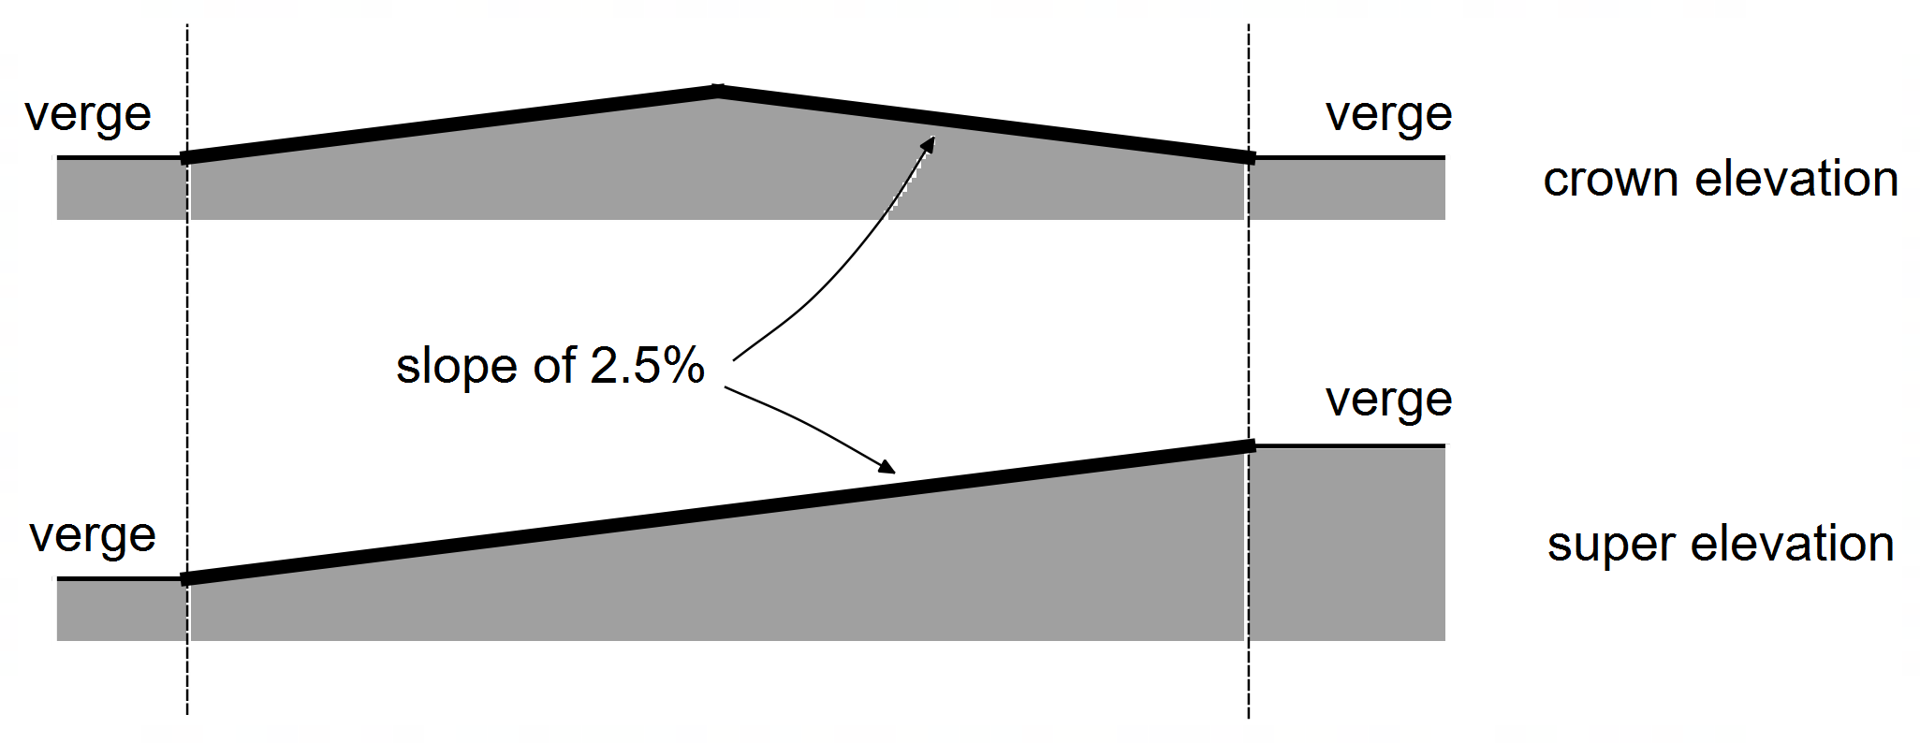

**Figure 1** typical elevation profiles of roads

When the car is on a banked turn, the normal force is no longer vertical. The normal force now has a horizontal component and this component acts to accelerate the car around the curve. The car will have to move with just the right speed to match the component of the normal force or otherwise will need to rely on friction. Figure 2 on the next page shows the forces acting on a car travelling on a banked curve.

The frictional force provided by contact between the road and the tyres is given by:

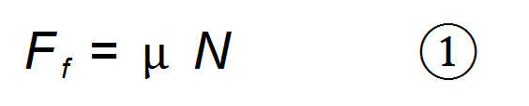

Where *Ff* is the frictional force,  is the coefficient of friction and *N* is the normal force.

The coefficient of friction  is a dimensionless number. It indicates the fraction of the normal force that can be provided as friction. Whilst normally  < 1 it is not impossible for  > 1 in cases where specially designed tyres are used that have exceptional grip.

The coefficient of friction is 0.7 on dry roads and 0.4 for damp roads. On a hot, dry day the coefficient of friction might be as high as 0.9. On wet roads the coefficient of friction can be as low as 0.1.

For a vehicle on a banked curve, the horizontal component of both *Ff* and *N* helpprovide the centripetal force needed to accelerate the car in a horizontal circle, whilst the vertical component of the normal force counteracts the weight of the car and any vertical component of the friction force.

For a car travelling on a banked curve relying on friction (Figure 2), the maximum speed is given by

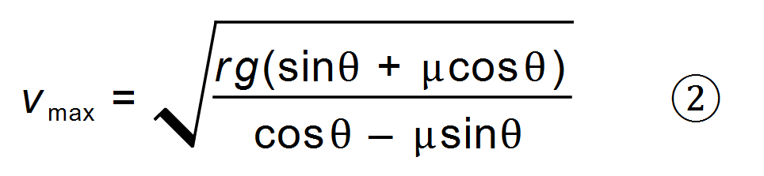

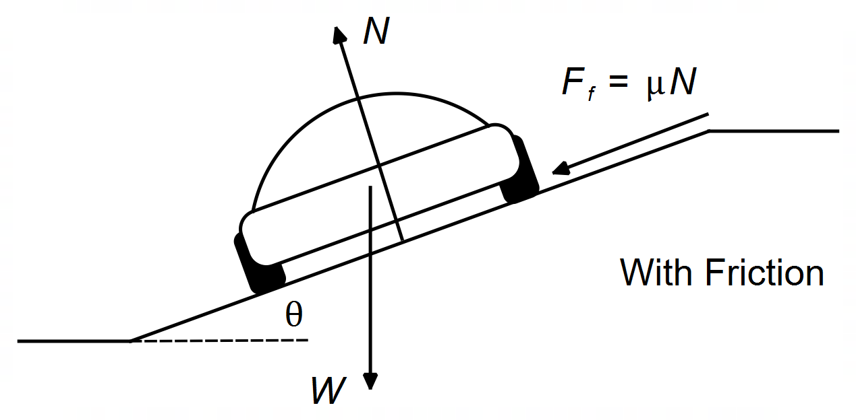

**Figure 2** Forces on a car on a banked curve – with friction

For a car travelling on a banked curve without friction (Figure 3), the maximum speed is given by:

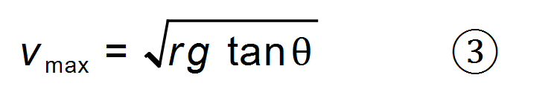

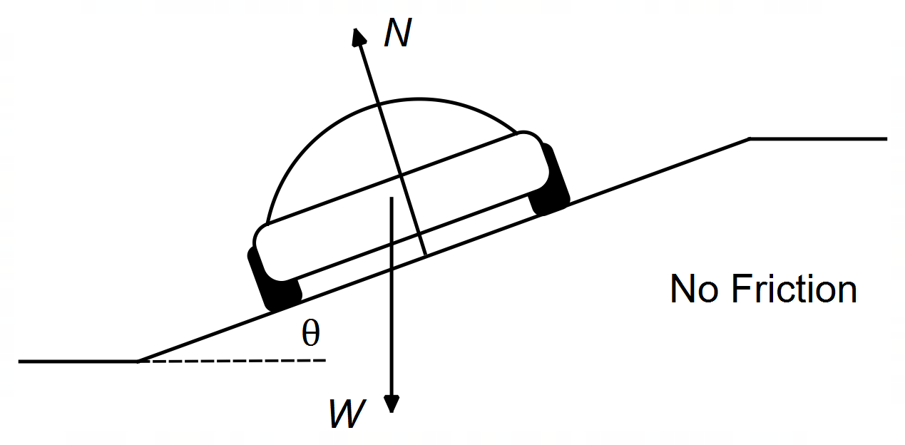

**Figure 3** Forces on a car on a banked curve – no friction

1. Briefly explain why a “crown elevation” road profile is not suitable for the design of a road surface where cars are travelling around a corner. (2 marks)

__________________________________________________________________________

__________________________________________________________________________

__________________________________________________________________________

1. Determine the angle  for a “super elevated” road with a slope of 2.5%. (1 mark)

Angle ____________ °

1. Without using equation 2, show that the maximum speed of a car navigating a corner on flat ground with friction is given by the expression: (3 marks)

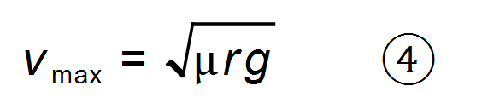

1. Calculate the three (3) possible maximum speeds that a car could navigate a bend on a road with a radius 46 m on a normal, dry day under the three following conditions (note: if you could not determine  for part (b) then use  = 2.0°): (4 marks)

Condition 1: the road is flat, and the car is relying on friction,

Condition 2: the road is “super-elevated”, and the car is relying on friction,

Condition 3: the road is “super-elevated”, and the car is not relying on friction.

Condition 1 ____________ m s–1

Condition 2 ____________ m s–1

Condition 3 ____________ m s–1

1. A sports car is navigating a racecourse with seven bends which are all on flat ground. The driver of the sports car drives as fast as possible without their car skidding around each corner. For each bend, the radius; the maximum velocity; and the square root of radius are listed in the table below.

|  |  |  |  |
| --- | --- | --- | --- |
| **Corner** | **Radius *r* (m)** | **Velocity *v* (m s-1)** |  |
| 1 | 19.1 | 12.5 | 4.37 |
| 2 | 8.30 | 8.90 | 2.88 |
| 3 | 41.5 | 18.0 | 6.44 |
| 4 | 68.0 | 23.4 | 8.25 |
| 5 | 31.5 | 16.7 | 5.61 |
| 6 | 114 | 31.0 | 10.7 |
| 7 | 54.0 | 20.7 | 7.35 |

1. Use the information in the table to graph the velocity *v* versus the square root of radius on the set of axes provided below. Draw a line of best fit. (3 marks)

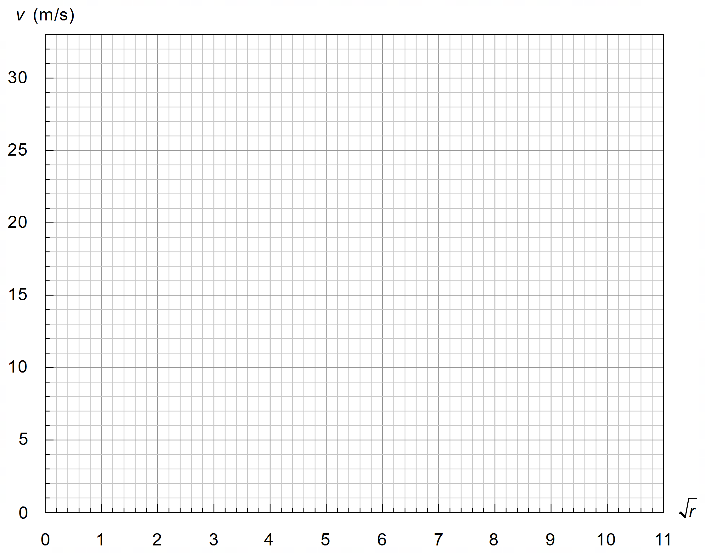

1. Determine the gradient for your line of best fit and use it to estimate a value for the coefficient of friction µ on the racecourse. Indicate clearly how you used your graph to calculate the gradient. Give your answer to an appropriate number of significant figures. Based on your result, explain the likely conditions of the road that day. (5 marks)

Coefficient of Friction ____________

Explanation

____________________________________________________________________

____________________________________________________________________

**THIS PAGE HAS BEEN LEFT BLANK INTENTIONALLY**

**Question 20 (18 marks)**

**Galvanometers**

A galvanometer is a device that measures electric current. The word galvanometer comes from the word *galvanic* which has to do with the production of electric current in galvanic cells (electrochemical cells). A galvanometer is like an ammeter in that they both measure current. However, a galvanometer can only measure DC current, whereas an ammeter can measure both DC and AC current.

The design of a galvanometer uses the idea that when a wire carrying a current is placed in a permanent magnetic field the wire will experience a force perpendicular to the direction of the current and magnetic field and proportional to the size of the current.

To use this force, the wire coil is wrapped around a metal core which is attached to a torsion spring and a thin needle. As the coil experiences a torque and rotates, the torsion spring provides an opposing torque. The needle moves across a calibrated scale, allowing the current to be measured.

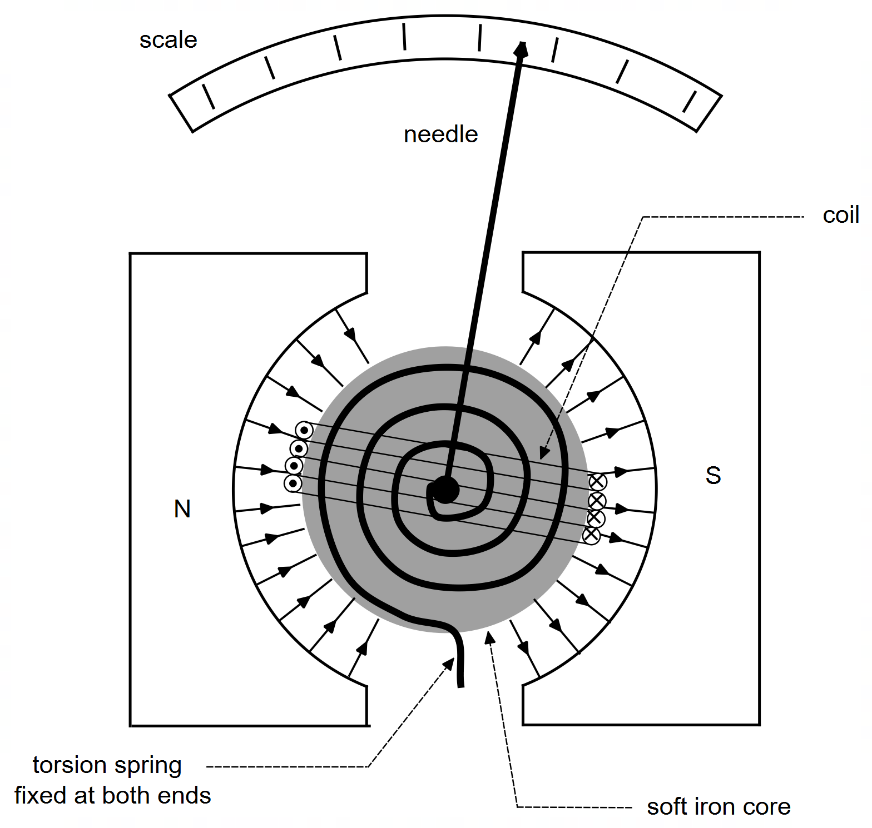

**Figure 4** Design of a galvanometer

The torque provided by the spring depends on the angle  that the coil and core rotate from their original position, as well as the stiffness of the torsion spring. The amount of torque provided by the spring is given by

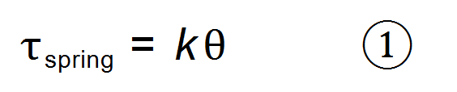

where  is the angle in degrees (°) and *k* is the stiffness of the spring (Nm per °).

The torque provided by the interaction of the coil and the permanent magnetic field is given by:

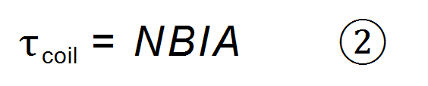

where *N* is the number of turns of wire, *B* is the strength of the magnetic field (T); *I* is the current (A) flowing in the coil; and *A* is the area of the coil (m2).

At the point when the needle comes to rest, the torque due to the coil balances the torque provided by the spring:

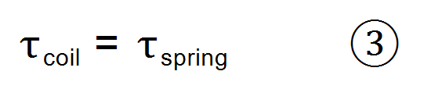

Galvanometers developed from the observation that a compass moves near a current-carrying wire, first noticed by Hans Christian Ørsted in 1820. As the galvanometer developed, corrections have been made to make it more accurate, but few have been needed to increase precision. For example, the stiffness of the spring needs to be constant to ensure that the resulting measurement of current is accurate. Also, the magnetic field needs to be uniform between the soft iron core and the poles of the permanent magnet to provide a consistent increase in force. Despite these major design challenges, galvanometers still offer a high level of precision in their measurements, especially for very small currents.

One of the benefits of a DC galvanometer is that coil is wound around a metallic core (soft iron usually). This means that when the coil rotates, there are small eddy currents formed in the metallic core that help with ‘electromagnetic damping’. These small currents help ensure that the needles come to rest quicker at the correct reading. Without these eddy currents formed in the core, the needle would oscillate back and forth much longer due to the momentum of the core, coil, and needle.

1. On Figure 4, indicate the direction of the torque provided by the coil. (1 mark)
2. Explain the importance of the circular shape of the permanent magnets. (3 marks)

__________________________________________________________________________

__________________________________________________________________________

__________________________________________________________________________

__________________________________________________________________________

__________________________________________________________________________

1. State two (2) likely sources of an inaccurate reading when using a galvanometer. (2 marks)

__________________________________________________________________________

__________________________________________________________________________

__________________________________________________________________________

1. With reference to relevant physics concepts, explain how eddy currents in the metal core help the needle of a DC galvanometer to quickly come to a reading without vibrating back and forth.

(4 marks)

__________________________________________________________________________

__________________________________________________________________________

__________________________________________________________________________

__________________________________________________________________________

__________________________________________________________________________

__________________________________________________________________________

__________________________________________________________________________

__________________________________________________________________________

1. Ideally, the angle of deviation of the needle of a galvanometer should be directly proportional to the current in the coil. In other words: Use equation 3 to determine an expression for the constant *C*. (2 marks)
2. A certain galvanometer has a rectangular 3.0 cm by 4.0 cm coil wrapped around a soft iron metal core. The core is attached to a torsion spring with stiffness *k* = 3.5 × 10-3 Nm per °. The coil and core arrangement sit in the region between two circular magnetic poles with a magnetic field strength of 550 mT. The coil has 38 turns of wire.
3. Determine the angle the needle deviates when a known current of 1.76 A passes through the coil. (3 marks)

Angle ____________ °

1. Unfortunately, the scale on the galvanometer is no longer legible. An unknown current is passed through the device such that the needle deviates exactly three divisions, through an angle of 21.5°. How much current (A) is represented by each division on the scale? (3 marks)

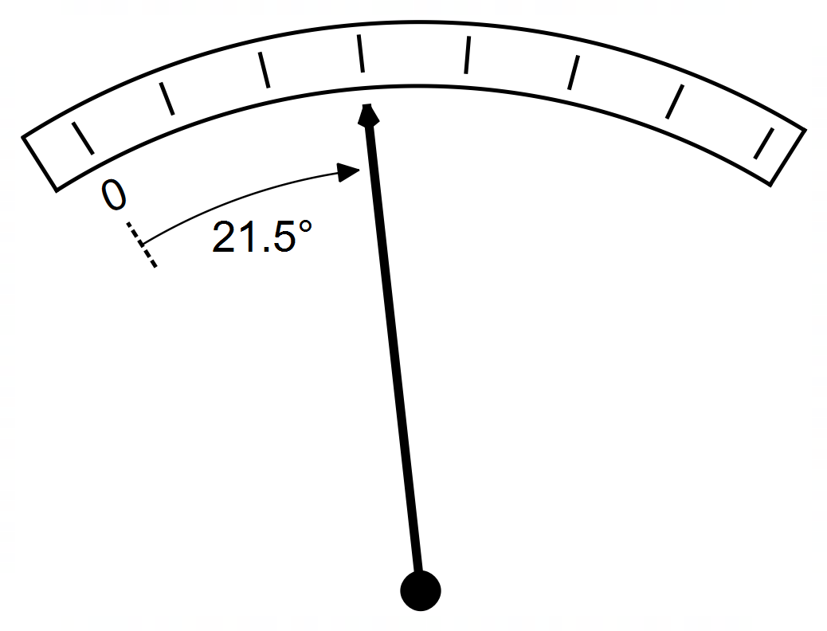

Each division ____________ A

**END OF EXAMINATION**

**Extra Working Space**

**Extra Working Space**

**Spare Graphs for Question 14**

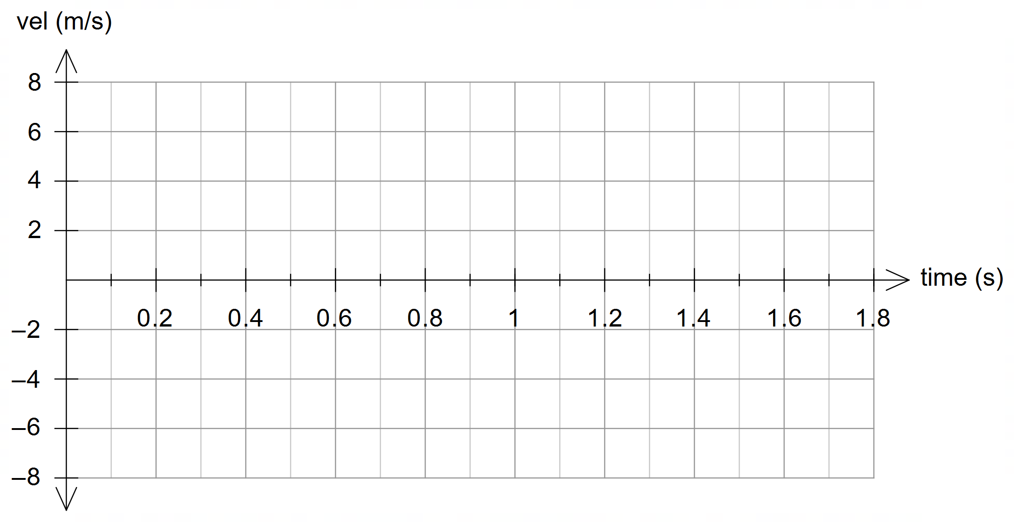

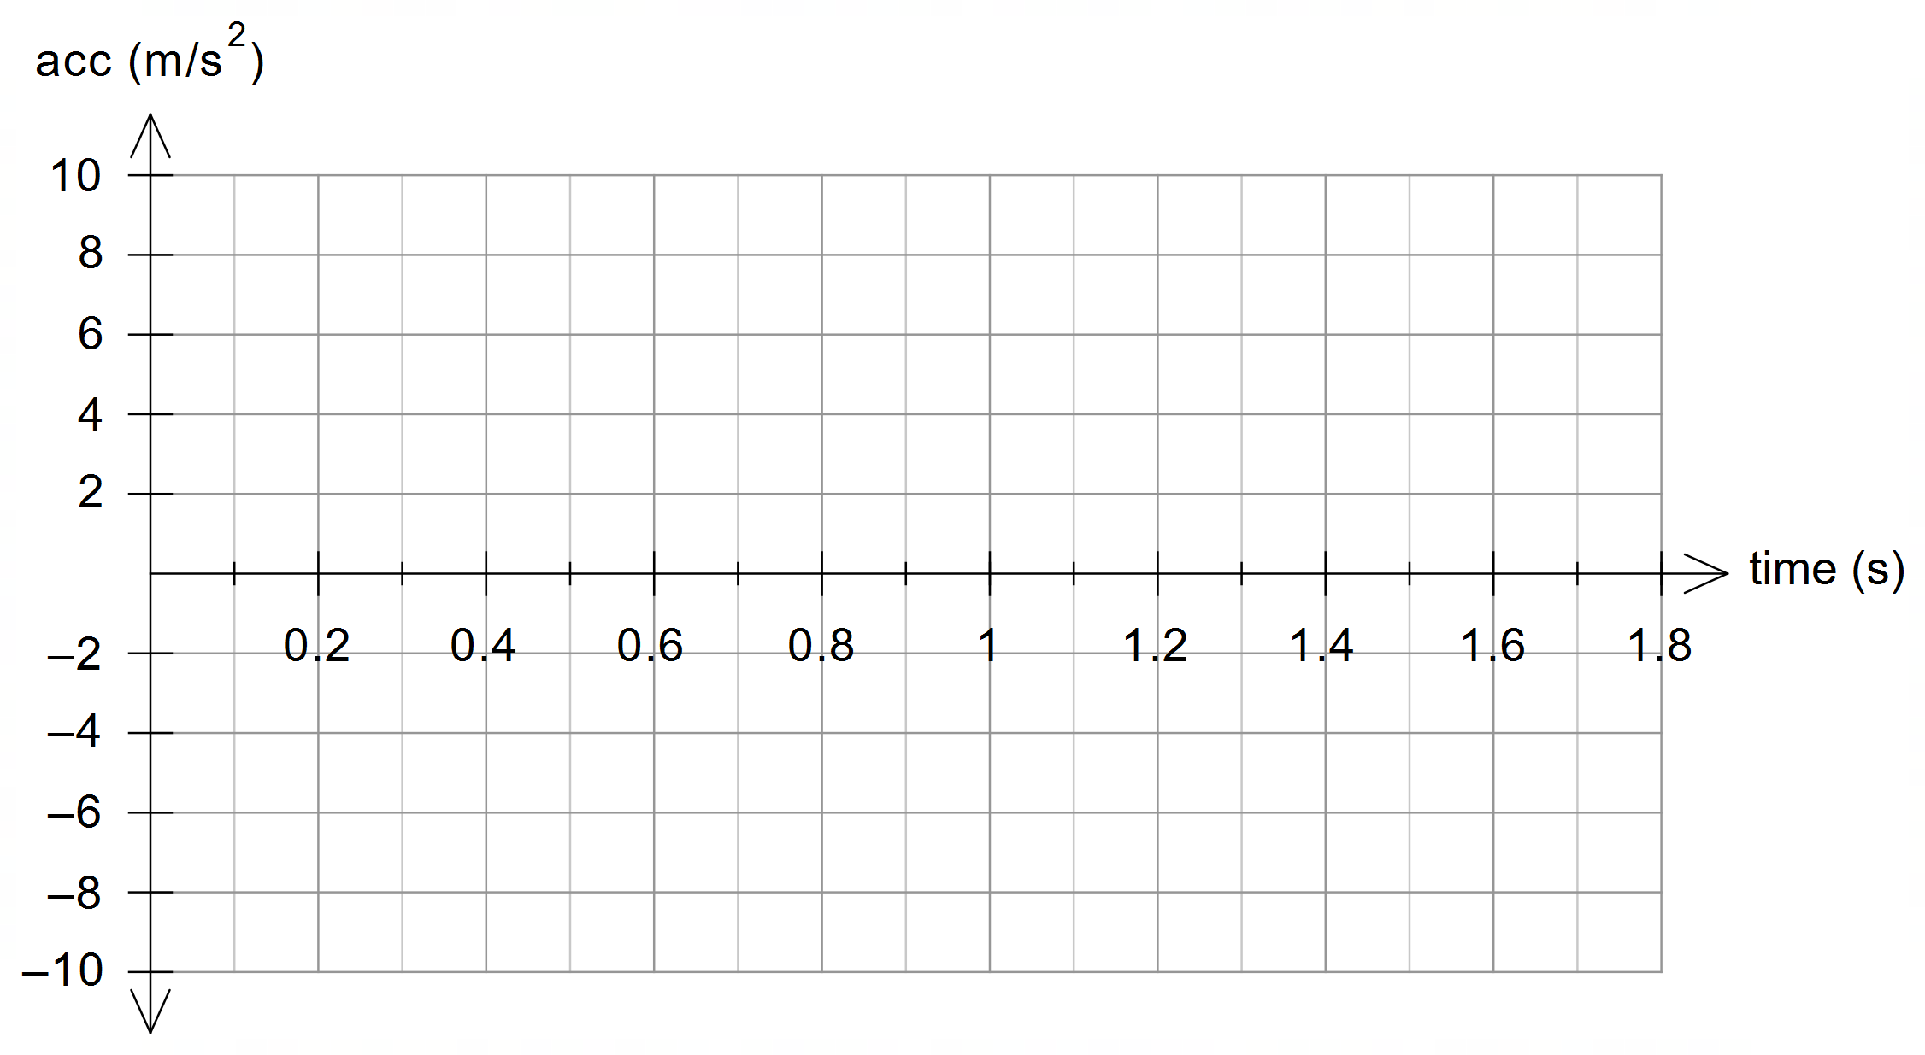

**Spare Graph for Question 19**

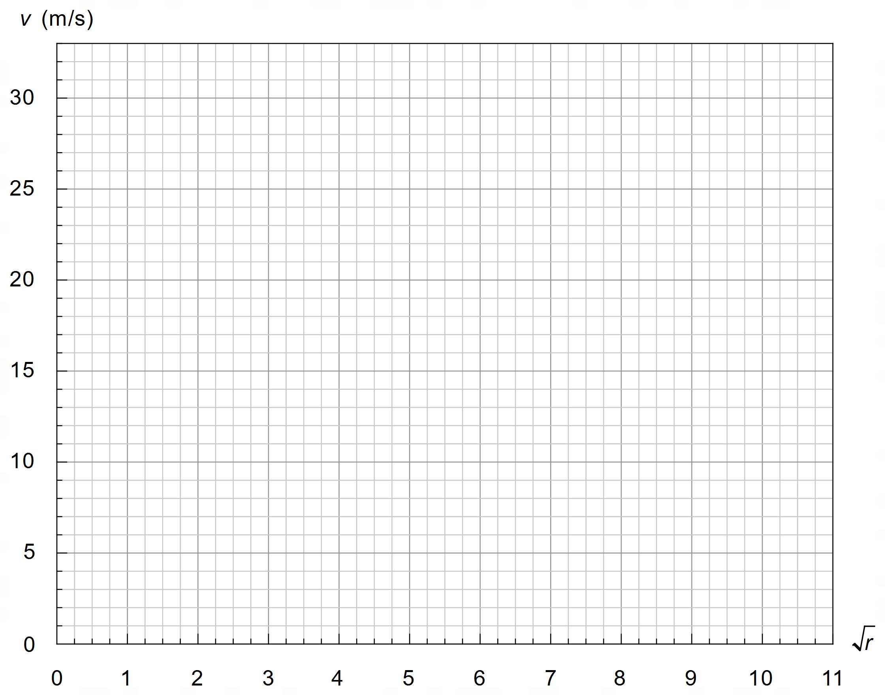

**Acknowledgements**

**Question 19** Equation 1, 2, 3 and 4 adapted from Hyperphysics, C.R. Nave, 2017, *Maximum Speed on Banked Roadway*, retrieved November 2, 2020, from: http://hyperphysics.phy-astr.gsu.edu/hbase/Mechanics/carbank.html

Information about coefficient of friction values from Hyperphysics, C.R. Nave, 2017, *Friction and Automobile Tyres*, http://hyperphysics.phy-astr.gsu.edu/hbase/Mechanics/frictire.html

**Question 20** Information in paragraphs 9 and 10 adapted from Wikipedia, 2020, *Galvanometer*, retrieved November 3, 2020, from: https://en.wikipedia.org/wiki/Galvanometer

**WATP acknowledges the permission of School Curriculum and Assessment Authority in**

**providing instructions to students.**